Assignment:
Break Out Session 2.

Group:
Group 1: Cason Konzer, Tom Green, Mike Turley.

Instructions:
One use case diagram and one narrative use case (from one of the use case goals).

Deliverable:

Use Case Diagram:

Actor: Cashier
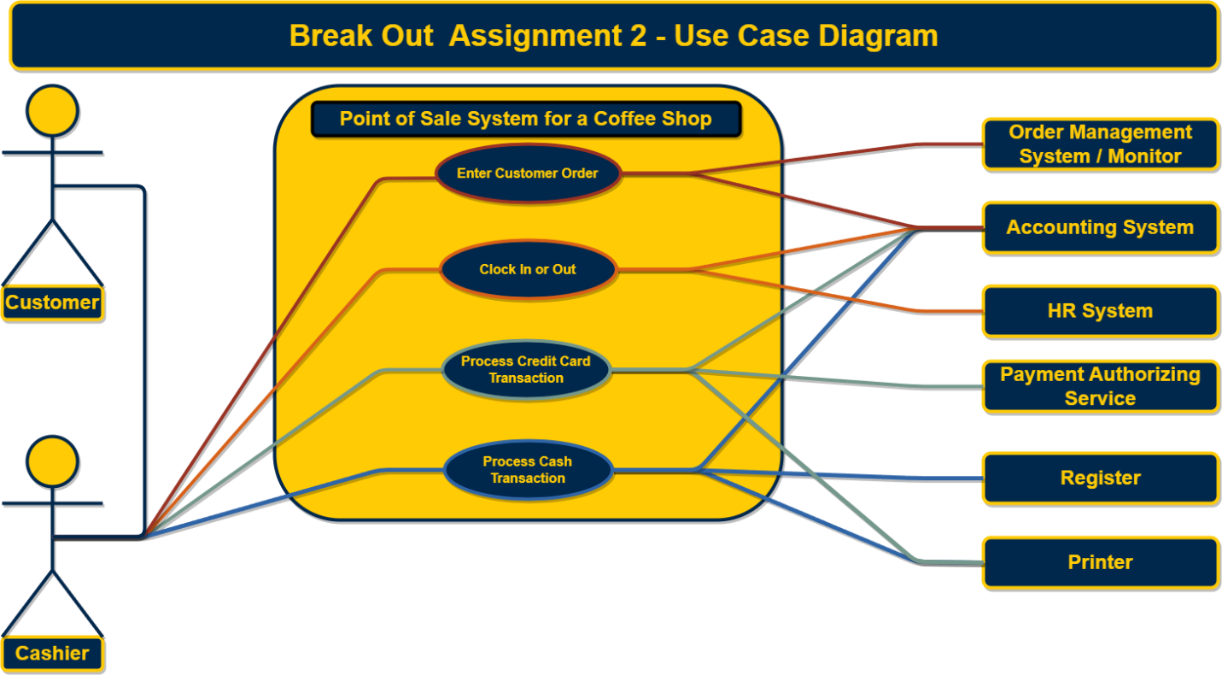

Narrative:

Actor: Cashier

Action: Enter Customer Order
- Precondition.
  - The customer arrives at the register or drive through.
  - The cashier greets the customer and requests order.
- Trigger
  - The customer provides details on the requested order.
- The cashier enters order details into the point-of-sale system.
- The point-of-sale system processed the order.
  - The point-of sale system sends order details to the order management system / monitor.
  - The point-of-sale system deducts the order inventory within the accounting system.
  - The point-of-sale system displays to the cashier an `order was successfully placed` message.
- Post-condition.
  - The cashier informs the customer that their order was successfully placed.

